**Geometry Vocabulary**

**Week 11**

**Acute Triangle**

Definition:  
If an angle measures more than 0° but less than 90°, the angle is **acute.**

Illustration:

contentABC below is an acute angle.

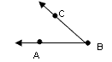

Examples:

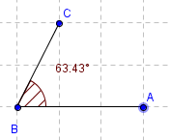

**Congruent Angles**

Definition: Congruent Angles have the same angle.

Illustration:

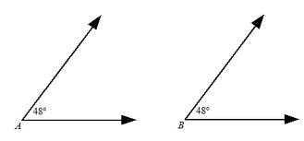

Examples:

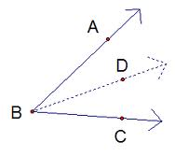

**Acute Angle**

Definition: An angle that is less than 90 degrees.

Illustration:

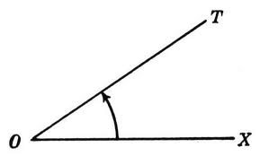

Examples:

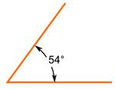

**Right Angle**

Definition: A right angle is exactly 90 degrees.

Illustration:

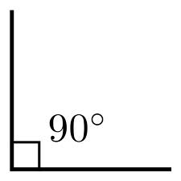

Examples:



**Obtuse Angle**

Definition: An angle larger than 90 degrees, but less than 180.

Illustration:

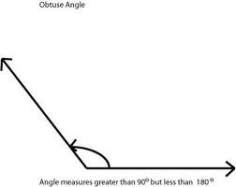

Examples:

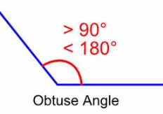

**Straight Angle**

Definition: A straight angle is 180 degrees.

Illustration:

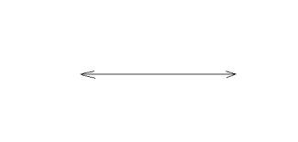

Examples:

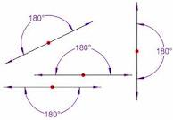

**Reflex Angle**

Definition: A reflex angle is more than 180 degrees but less than 360 degrees.

Illustration:

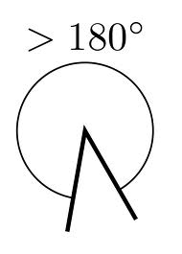

Examples:

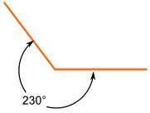

**Adjacent Angles**

Definition: Two angles are Adjacent if they have a common side and a common vertex.

Illustration:

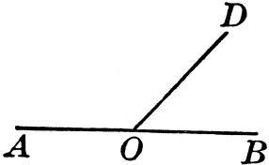

Examples:

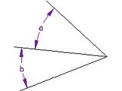

**Supplementary Angles**

Definition: Two angles are supplementary if they add up to 180 degrees.

Illustration:

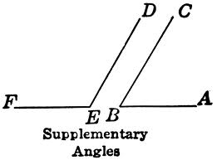

Examples:

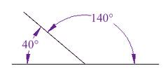

**Complementary Angles**

Definition: Two angles are complementary if they add up to 90 degrees.

Illustration:

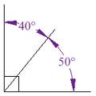

Examples:

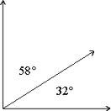

**Vertical Angles**

Definition: Vertical Angles are the angles opposite each other when two lines cross.

Illustration:

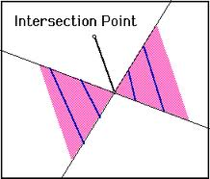

Examples:

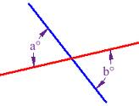

**Angle Bisector**

Definition: A line or ray that divides an angle in half.

Illustration:

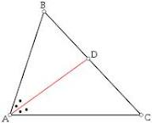

Examples:

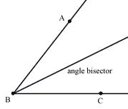

**Linear Pair**

Definition: Two angles that are adjacent and supplementary.

Illustration:

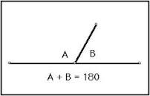

Examples: Angles 3 and 4 are a linear pair.

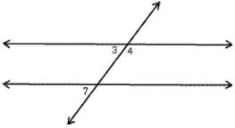

**Protractor**

Definition: An instrument for measuring angles.

Illustration:

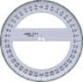

Examples:

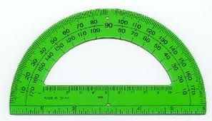

**Angle Addition Postulate**

Definition: States that if a point S lies in the interior of <PQR, then

<PQS + <SQR = <PQR

Illustration:

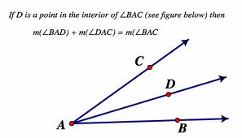

Examples: <BOC + <AOB = <PQR

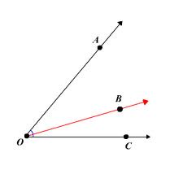

**Perpendicular Lines**

Definition: A line is perpendicular to another if they meet at 90 degrees.

Illustration:

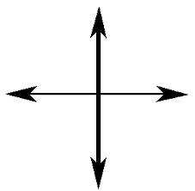

Examples:

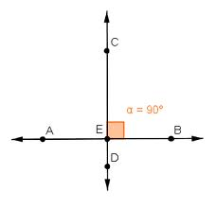

**Parallel Lines**

Definition: Lines are parallel if they are always the same distance apart.

Illustration:

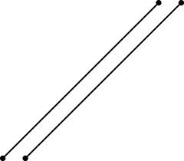

Examples:

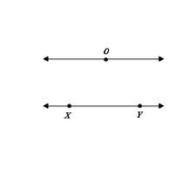

**Transversal Lines**

Definition: A line that cuts across two or more lines.

Illustration:

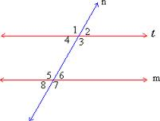

Examples:



**Alternate Interior Angles**

Definition: Pairs of angles on opposite sides of the transversal but inside the two lines.

Illustration:

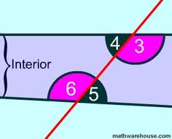

Examples: Angle 3 and 6 are alternate interior angles.

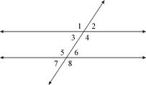

**Alternate Exterior Angles**

Definition: Pairs of angles on opposite sides of the transversal but outside the two lines.

Illustration:

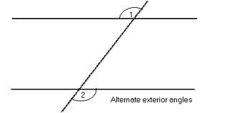

Examples:

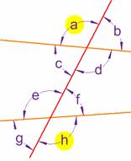

**Corresponding Angles**

Definition: Two congruent angles, both lying on the same side of the transversal and situated the same way on two different parallel lines.

Illustration:

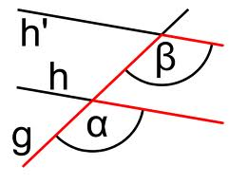

Examples: Angle C and B are corresponding angles.

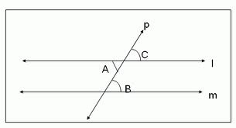

**Consecutive Interior Angles**

Definition: The pairs of angles on one side of the transversal but inside the two lines.

Illustration:

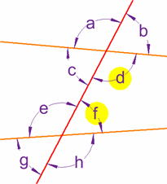

Examples:

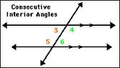

**Same-Side Exterior Angles**

Definition: Two angles outside the two parallel lines along the same side of a transversal line.

Illustration: Angle 1 and 7

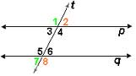

Examples: Angles E and F

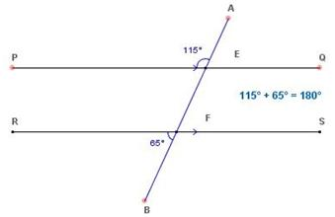

**Week 12 Vocabulary**

**Acute Triangle**

Definition: A triangle each of whose angles measures less than 90 degrees.

Illustration: 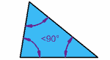

Examples: 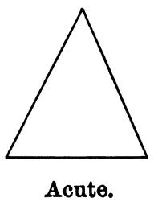

**Right Triangle**

Definition: A triangle that contains a right angle.

Illustration: [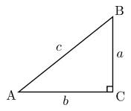](http://www.google.com/imgres?um=1&hl=en&sa=N&biw=1306&bih=597&tbm=isch&tbnid=WbzQkf4HnLfqnM:&imgrefurl=http://en.wikipedia.org/wiki/Right_triangle&docid=FH8MUTlx2ED4HM&imgurl=http://upload.wikimedia.org/wikipedia/commons/thumb/6/6f/Rtriangle.svg/220px-Rtriangle.svg.png&w=220&h=187&ei=R-8BT_fWHon-ggeP2biMDg&zoom=1)

Examples: [](http://www.google.com/imgres?um=1&hl=en&sa=N&biw=1306&bih=597&tbm=isch&tbnid=55gV3Pca3MzYkM:&imgrefurl=http://www.dpchallenge.com/image.php?IMAGE_ID=174560&docid=Ibmz00GCNKnmQM&imgurl=http://images.dpchallenge.com/images_challenge/0-999/338/800/Copyrighted_Image_Reuse_Prohibited_174560.jpg&w=640&h=481&ei=R-8BT_fWHon-ggeP2biMDg&zoom=1)

**Obtuse Triangle**

Definition: A triangle with an obtuse angle.

Illustration: [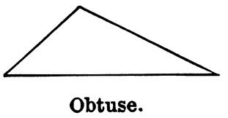](http://www.google.com/imgres?um=1&hl=en&biw=1306&bih=597&tbm=isch&tbnid=8XImekHTyjtd4M:&imgrefurl=http://etc.usf.edu/clipart/38600/38600/triwent7_38600.htm&docid=NPhuOxgxd400fM&imgurl=http://etc.usf.edu/clipart/38600/38600/Triwent7_38600_lg.gif&w=700&h=366&ei=be8BT4yKAuLu0gGQh6iXAg&zoom=1)

Examples: [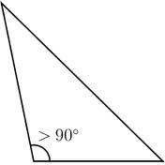](http://www.google.com/imgres?um=1&hl=en&biw=1306&bih=597&tbm=isch&tbnid=IWscTQ2cEosjMM:&imgrefurl=http://en.wiktionary.org/wiki/obtuse_triangle&docid=GbcpkzQJmR6cMM&imgurl=http://upload.wikimedia.org/wikipedia/commons/thumb/0/05/Triangle.Obtuse.svg/220px-Triangle.Obtuse.svg.png&w=220&h=220&ei=be8BT4yKAuLu0gGQh6iXAg&zoom=1)

**Equiangular Triangle**

Definition: A triangle with equal angles.

Illustration: [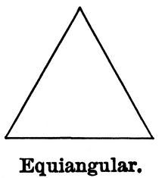](http://www.google.com/imgres?um=1&hl=en&biw=1306&bih=597&tbm=isch&tbnid=ug_yq0XOXpZS_M:&imgrefurl=http://etc.usf.edu/clipart/38600/38602/triwent9_38602.htm&docid=HQDGs_fV23D2FM&imgurl=http://etc.usf.edu/clipart/38600/38602/Triwent9_38602_lg.gif&w=700&h=769&ei=lu8BT4-eKNTTgQf1gJm1Ag&zoom=1)

Examples: [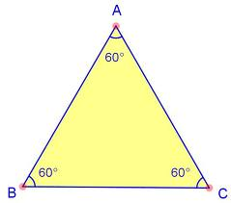](http://www.google.com/imgres?um=1&hl=en&biw=1306&bih=597&tbm=isch&tbnid=TTyPwFTn8j9lJM:&imgrefurl=http://www.proprofs.com/flashcards/story.php?title=geometry-flashcards_6&docid=iHLZXx4cg0_NfM&imgurl=http://www.proprofs.com/flashcards/upload/a3979269.jpg&w=525&h=465&ei=lu8BT4-eKNTTgQf1gJm1Ag&zoom=1)

**Scalene Triangle**

Definition: A triangle with three unequal sides.

Illustration:

Examples:

**Equilateral Triangle**

Definition: A triangle that has three equal sides.

Illustration:

Examples:

**Isosceles Triangle**

Definition: A triangle with at least two equal sides.

Illustration:

Examples:

**Triangle Sum Theorem**

Definition: The sum of the interior angles of any triangle is equal to 180 degrees.

Illustration:

Examples:

**Exterior Angle Theorem**

Definition: An measure of an exterior angle of a triangle is equal to the sum of the measures of the two non-adjacent interior angles.

An exterior angle is formed by one side of a triangle and the extension of an adjacent side of the triangle.

Illustration: 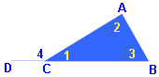

Examples:

**Orthocenter**

Definition:

Illustration:

Examples:

**Centroid**

Definition:

Illustration:

Examples:

**Incenter**

Definition:

Illustration:

Examples:

**Circumcenter**

Definition:

Illustration:

Examples:

**Reflexive Property**

Definition:

Illustration:

Examples:

**SSS Postulate (Side-Side-Side)**

Definition:

Illustration:

Examples:

**SAS Postulate (Side-Angle-Side)**

Definition:

Illustration:

Examples:

**ASA Postulate (Angle-Side-Angle)**

Definition:

Illustration:

Examples:

**AAS Theorem (Angle-Angle-Side)**

Definition:

Illustration:

Examples:

**HL Theorem (Hypotenuse-Leg)**

Definition:

Illustration:

Examples:

**Corresponding-Parts-of-Congruent-Triangles (CPCTC)**

Definition:

Illustration:

Examples:

**Week 13**

**Ratio**

Definition: The quantitative relation between two amounts showing the number of times one value contains or is contained within the other.

Illustration:

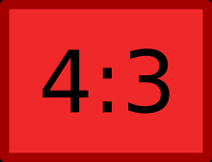

Examples:

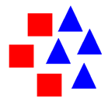

Write it as a fraction, using the word “to”, or using a semi colon

Proportion

Definition: A part, share, or number considered in comparative relation to a whole.

Illustration:

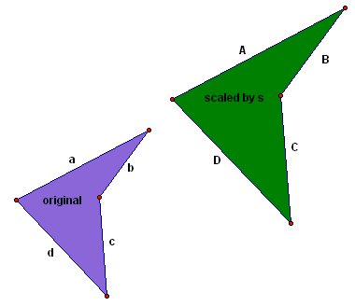

Examples:

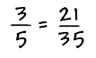

Congruent

Definition: Two objects are congruent if they have the same dimensions and shape

Illustration:

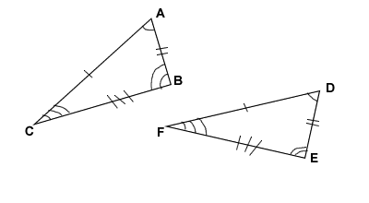

Examples:

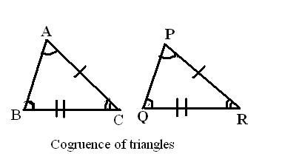

Similar Triangles

Definition: Triangles whose corresponding angles are equal; the corresponding sides are then proportional in length.

Illustration:

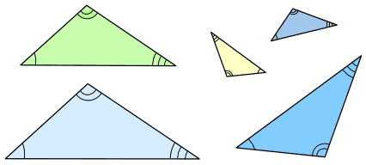

Examples:

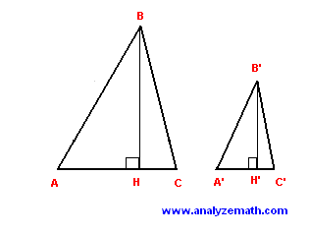

Corresponding Angles

Definition: Corresponding angles are created where a transversal crosses other (usually parallel) lines.

Illustration:

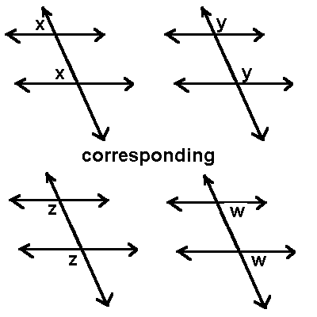

Examples:

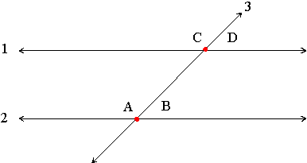

Cooresponding Sides

Definition: If the relative position of two sides is same in two figures

Illustration:

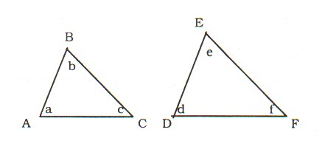

Examples:

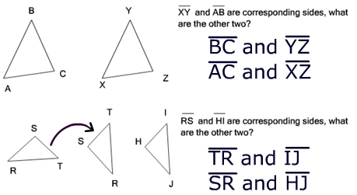  
Angle-Angle Similarity Postulate

Definition: states that if two angles and the non-included side one triangle are congruent to two angles and the non-included angle of another triangle, then these two triangles are congruent.

Illustration:

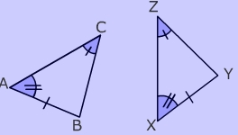

Examples:

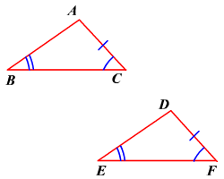

Side-Side-Side Similarity Postulate

Definition: Triangles are congruent if all three sides in one triangle are congruent to the corresponding sides in the other.

Illustration:

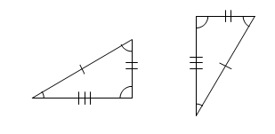

Examples:

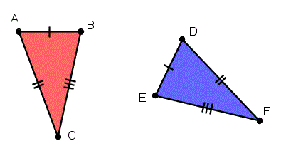

Side-Angle-Side Similarity Postulate

Definition: If two sides and the included angle of a triangle are congruent to two sides and the included angle of another triangle, then the two triangles are congruent.

Illustration:

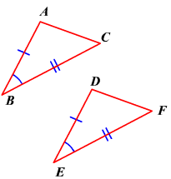

Examples:

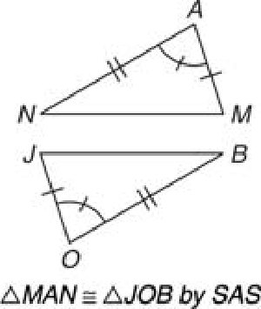

**Week 14**

the Pythagorean theorem

Definition: The theorem that the sum of the squares of the lengths of the sides of a right triangle is equal to the square of the length of the hypotenuse.

Illustration:

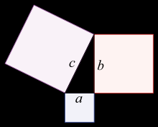

Examples:

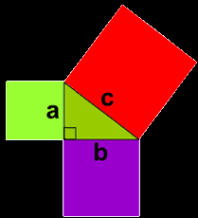  
Hypotenuse

Definition: The longest side of the triangle

Illustration:

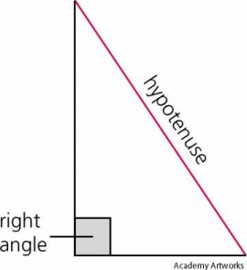

Examples:

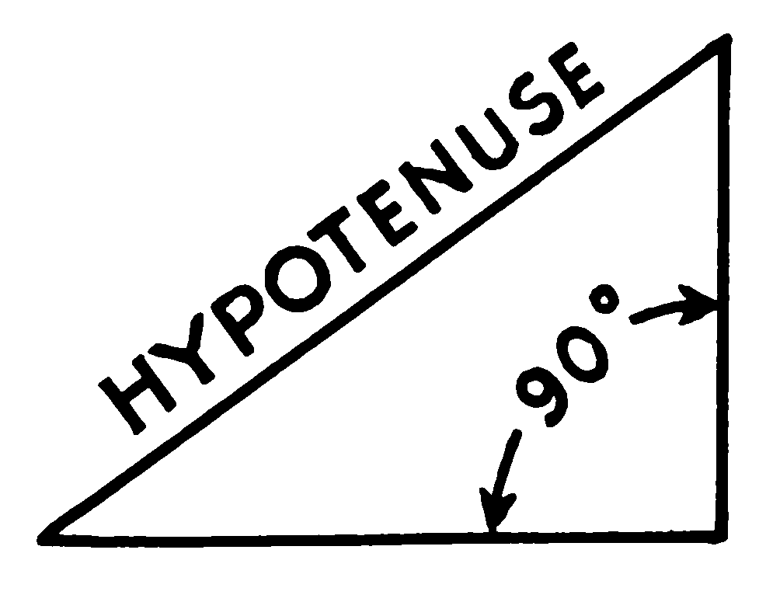  
Pythagorean Triples

Definition: consists of three positive integers a, b, and c, such that a2 + b2 = c2.

Illustration:

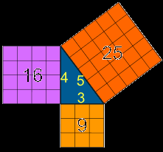

Examples:

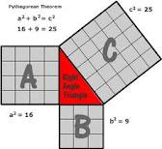  
The converse of the Pythagorean Theorem

Definition: the converse states that whenever the sum of the squares of two sides equal to the square of the third side of the triangle, the triangle is a right triangle.

Illustration:

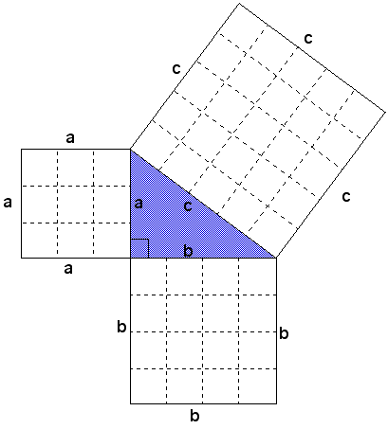

Examples:

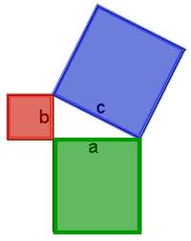

**Week 15**

30°-60°-90° triangle

Definition: is a special type of right triangle where the three angles measure 30 degrees, 60 degrees, and 90 degrees.

Illustration:

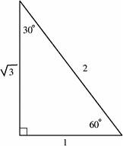

Examples:

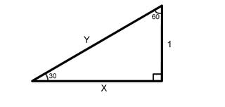  
45°-45°-90° triangle

Definition: A right triangle where the angles are 45°, 45°, and 90°.

Illustration:

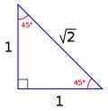

Examples:

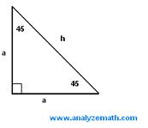  
Hypotenuse  
Opposite side of traingle

Definition:

Illustration:

Examples:

Adjacent side of a triangle

Definition:

Illustration:

Examples:

Sine

Definition: The trigonometric function that is equal to the ratio of the side opposite a given angle (in a right triangle) to the hypotenuse.

Illustration:

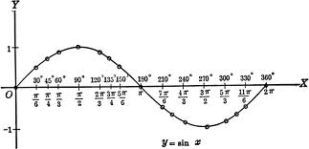

Examples:

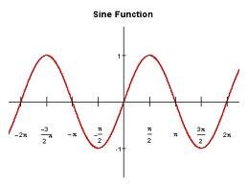

Cosine

Definition: The trigonometric function that is equal to the ratio of the side adjacent to an acute angle (in a right-angled triangle) to the hypotenuse.

Illustration:

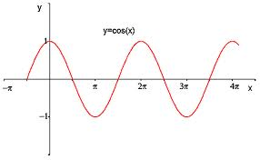

Examples:

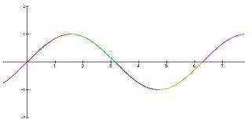  
Tangent

Definition:

Illustration:

Examples:

Angle of Depression

Definition:

Illustration:

Examples:

Inverse Sine

Definition:

Illustration:

Examples:

Inverse Cosine

Definition:

Illustration:

Examples:

Inverse Tangent

Definition:

Illustration:

Examples:

**Week 16**

Polygon

Definition:

Illustration:

Examples:

Regular Polygon

Definition:

Illustration:

Examples:

Irregular Polygon

Definition:

Illustration:

Examples:

Convex

Definition:

Illustration:

Examples:

Concave

Definition:

Illustration:

Examples:

Vertex

Definition:

Illustration:

Examples:

Interior Angle Sum Theorem

Definition:

Illustration:

Examples:

Exterior Angle Sum Theorem

Definition:

Illustration:

Examples:

Quadrilateral

Definition:

Illustration:

Examples:

Parallelogram

Definition:

Illustration:

Examples:

Rectangle

Definition:

Illustration:

Examples:

Rhombus

Definition:

Illustration:

Examples:

Square

Definition:

Illustration:

Examples:

Trapezoid

Definition:

Illustration:

Examples:

Kite

Definition:

Illustration:

Examples:

Consecutive Angles

Definition:

Illustration:

Examples:

Supplementary Angles

Definition:

Illustration:

Examples:

Diagonal

Definition:

Illustration:

Examples:

Median

Definition:

Illustration:

Examples:

**Week 17**

Circle

Definition:

Illustration:

Examples:

Semi-Circle

Definition:

Illustration:

Examples:

Radius

Definition:

Illustration:

Examples:

Diameter

Definition:

Illustration:

Examples:

Circumference

Definition:

Illustration:

Examples:

Chord

Definition:

Illustration:

Examples:

Secant

Definition:

Illustration:

Examples:

Tangent

Definition:

Illustration:

Examples:

Central Angle

Definition:

Illustration:

Examples:

Inscribed Angle

Definition:

Illustration:

Examples:

Arc Addition Postulate

Definition:

Illustration:

Examples:

Arc Lenght Formula

Definition:

Illustration:

Examples:

Sector of a Circle

Definition:

Illustration:

Examples:

Area of a Sector Formula

Definition:

Illustration:

Examples:

**Week 18**

Perimeter

Definition:

Illustration:

Examples:

Area

Definition:

Illustration:

Examples:

Surface Area

Definition:

Illustration:

Examples:

Volume

Definition:

Illustration:

Examples:

Geometric Net

Definition:

Illustration:

Examples:

Prism

Definition:

Illustration:

Examples:

Cylinder

Definition:

Illustration:

Examples:

Circle

Definition:

Illustration:

Examples:

Circumference

Definition:

Illustration:

Examples:

Radius

Definition:

Illustration:

Examples:

Diameter

Definition:

Illustration:

Examples:

Pyramid

Definition:

Illustration:

Examples:

Cone

Definition:

Illustration:

Examples:

Slant Height

Definition:

Illustration:

Examples:

Sphere

Definition:

Illustration:

Examples:

**Week 18 Pt. 2**

Consistent

Definition:

Illustration:

Examples:

Inconsistent

Definition:

Illustration:

Examples:

System of Equaitons

Definition:

Illustration:

Examples:

System of Inequalities

Definition:

Illustration:

Examples:

Inequality with a solid line

Definition:

Illustration:

Examples:

Inequality with a broken(dashed) line

Definition:

Illustration:

Examples:

**Lesson 13:**

Definition:

Illustration:

Examples:

**Lesson 14:**

Definition:

Illustration:

Examples:

**Lesson 15:**

Definition:

Illustration:

Examples:

**Lesson 16:**

Definition:

Illustration:

Examples:

**Lesson 17:**

Definition:

Illustration:

Examples:

**Lesson 18:**

Definition:

Illustration:

Examples: